Lab 6 – Introducing Jenny

Jenny is a command line based test case generator which support only for uniform strength interaction. Jenny tool is programmed based on Jenny’s t-way strategy [3] discussed in previous tutorial. By default, Jenny is a Windows® application, however, Jenny’s source code is available at *http://www.burtleburtle.net./bob/math/jenny.html* and can be compiled to suite any operating system.

To use Jenny is simply by running command prompt and locate the directory containing the executable file for Jenny. Jenny’s command line instruction is as shown .

|  |  |
| --- | --- |
| Usage:  *#> jenny –n[strength] [system configuration] –w[constraints]* | |
| *strength* | Interaction strength required for the SUT. Default value is 2. |
| *system configuration* | List of values starting with the first parameter.  (i.e. [2 2 2 2] represent a system with 4 2-valued parameters). |

Now, let’s use Jenny to generate the test cases required in order to test the SUT shown in Figure 1(a). The SUT is a 4 3-valued parameters system requiring interaction of strength 2. Thus, to generate the test cases using Jenny, the command required is:-

|  |
| --- |
| *#> jenny 3 3 3 3* **OR #***> jenny –n2 3 3 3 3* |

The first command can be used since the interaction strength required is Jenny’s default value for interaction strength which is two. The second command is more general command where “*-n2*” indicate the strength required is two and “*3 3 3 3*” tells the program that the first parameter of the SUT contains 3 value, the second parameter also contain 3 value and so on. The result will be displayed after Jenny finishes (see Figure below).

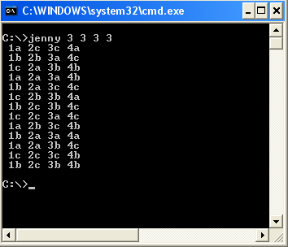

Here, Jenny does not provide real parameter values in the generated test cases. Instead, Jenny used symbolic representation in the generated test cases. Basically, Jenny represent input parameter with number (i.e. from 1 to 65535) and value with alphabet (a, …, z, A, …, Z). Therefore **1a** will represent the first value of the first parameter (for this case “-5V”), **1b** is the second value of the first parameter (i.e. “0V”), **2a** is the first value of the second parameter (i.e. “High”) **2b** is the first value of the second parameter (i.e. “Medium) and so on. The translation must be done manually since Jenny does not have automation in input-output mapping.